**JOB OFFER LETTER**

Contents

1 Process Overview 3

2 Introduction 3

3 Creation of Word Document with Custom fields 3

4 Save the template into MongoDB 5

5 Update the existing template 5

6 Generate the Offer Letters with custom fields in PDF format 6

# 

# Process Overview

The purpose of this document is to provide an overview of configuring custom fields and how to generate customized template using Job Offer Letter engine.

* Introduction
* Creation of Word Document with Custom fields.
* Save the template into MongoDB.
* Update the existing template (if required).
* Generate the Offer Letters with custom fields in PDF format.

# Introduction

Job offer letter engine is used to generate customized Job offer letters in PDF format. The user can able to add the custom fields in Word document (using built-in option) and this engine has been built to identify the custom variables and replaced it while generating the Offer Letters.

# Creation of Word Document with Custom fields

The steps to add custom variables are as below:

1. Create a new document with required details and focus the cursor on the point, where the custom fields to be placed. Keying Ctrl+F9, then curly brackets {} would appear on the focused point.
2. Right click on the curly brackets {} and click **Edit Field** option from option list.

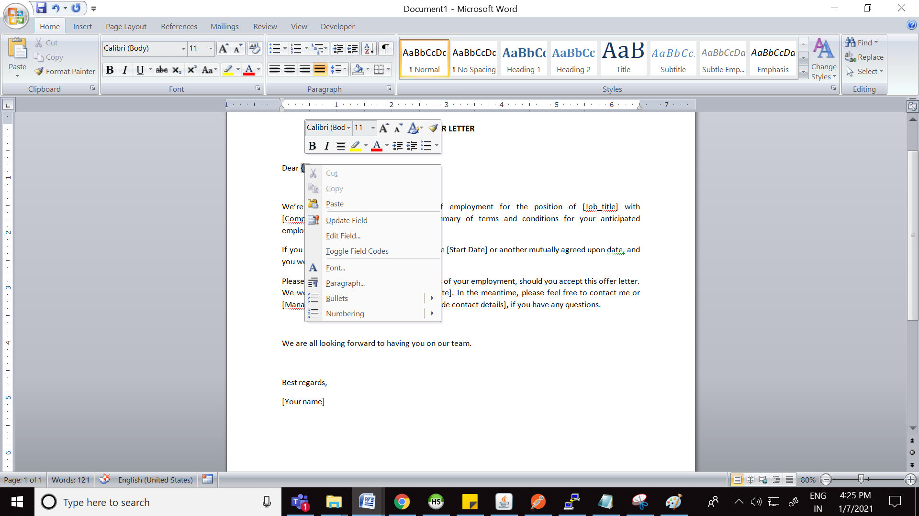

3. Choose ***MergeField*** from field names and enter the field name with following syntax ***$<dataset alia>.<fieldname>***

eg : $dt.candidate_name. And then click **OK** button.

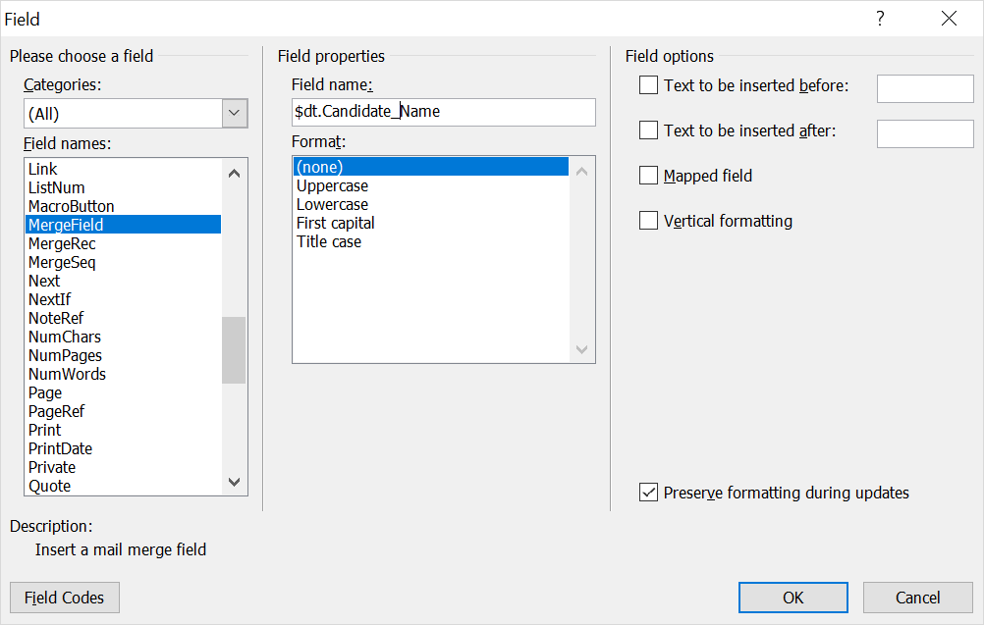

4. Once the field is configured, then the template will be as shown below: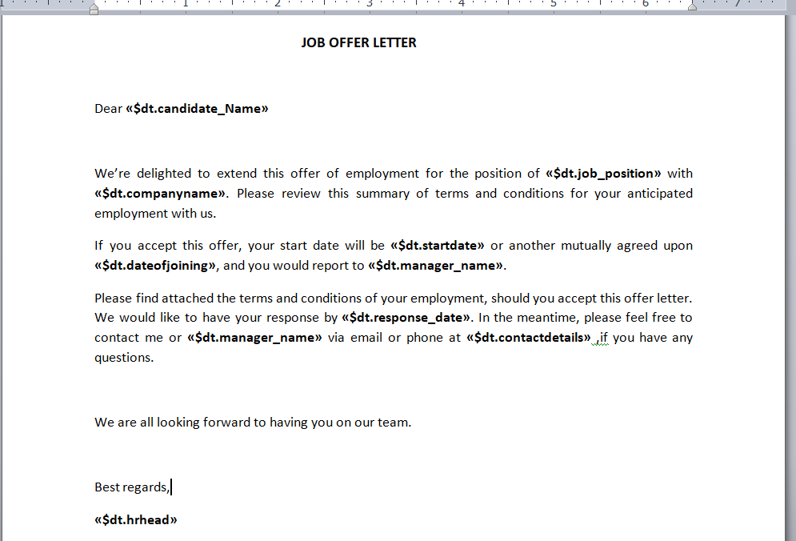

The configured fields will be replaced by user defined values

# Save the template into MongoDB

The user can upload the Job offer letter templates in below screen:

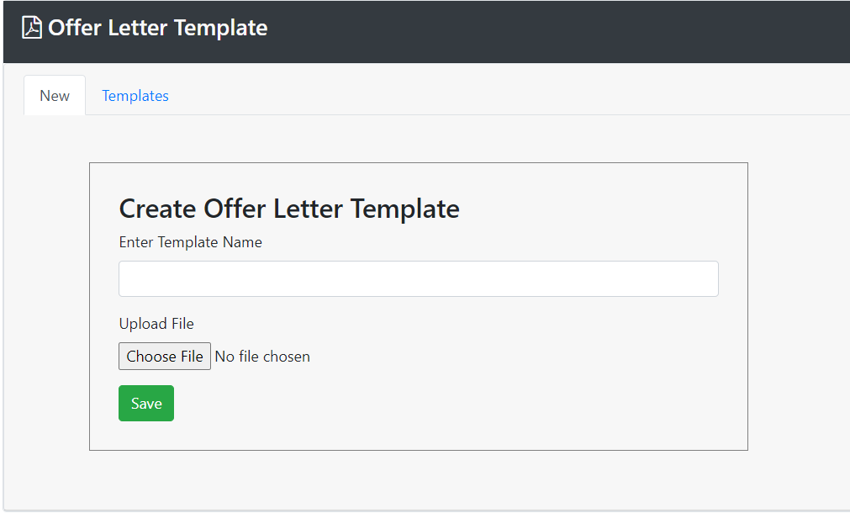

The File chooser only accepts files of DOCX format. The uploaded template has been saved in MongoDB with its corresponding Template Name.

# Update the existing template

The saved offer letter templates have been listed in below screen:

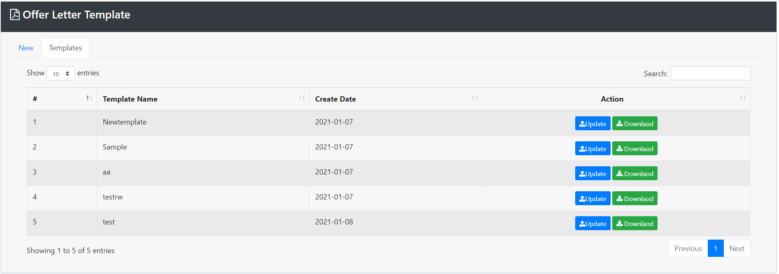

The user can update the offer letter template using update  button. While clicking on the update button the user will be prompted with below popup, to upload the document to be updated.

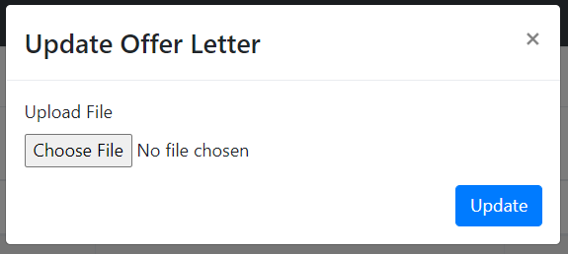

# Generate the Offer Letters with custom fields in PDF format

The user can download the Job offer letters. While clicking on the download  button, the custom variables against the selected Template will be prompted as below:

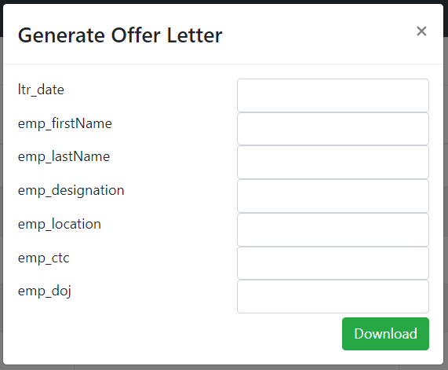

The values entered against each custom field will be passed to the engine with the required details of selected template. The offer letter engine will generate the template in DOCX format with the values append against each custom field respectively and finally it will convert the DOCX to PDF format, which will be downloaded to the users.